**1- Get the object url by object id**

{% set object = pimcore_object(4) %}

{{ pimcore_url({'object': object}) }}

**2- Make Rest Api in PimCore**

https://pimcore.com/docs/pimcore/current/Development_Documentation/Best_Practice/Building_Custom_Rest_APIs.html

* Create an controller in location src > controller >
* Name as CustomRestController.php
* Code as

<?php

namespace App\Controller;

use Pimcore\Model\DataObject;

use Symfony\Component\HttpFoundation\Request;

use Symfony\Component\HttpFoundation\Response;

use Symfony\Component\Routing\Annotation\Route;

use \Pimcore\Controller\FrontendController;

class CustomRestController extends FrontendController

{

/**

* @Route("/hello")

*/

public function defaultAction(Request $request)

{

// do some authorization here ...

return new response('test');

}

/**

* @Route("/TestMe")

*/

public function testAction()

{

# code...

$data[] = array(

"title" => 'Test Title',

"description" => 'Test Description',

"tags" => 'Test Tags');

return $this->json(["success" => true,"data" => $data]);

}

}

* To show the output hit URL as <http://skills-pimcore.local/TestMe> or

<http://skills-pimcore.local/hello>

**3- Create command for Object**

* Create Class like as Product

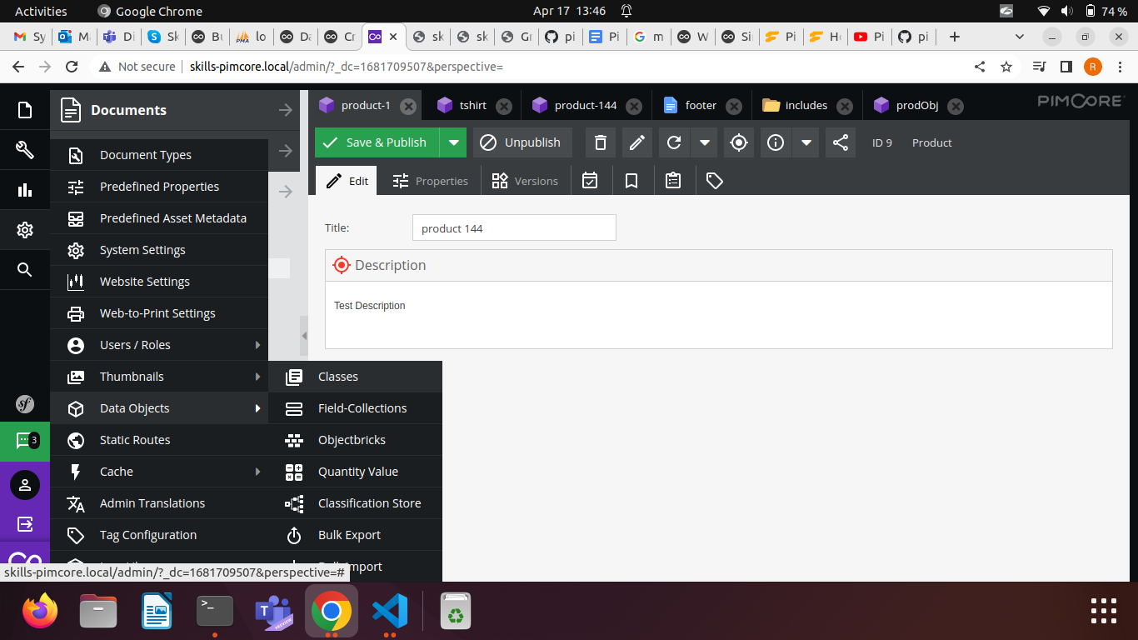

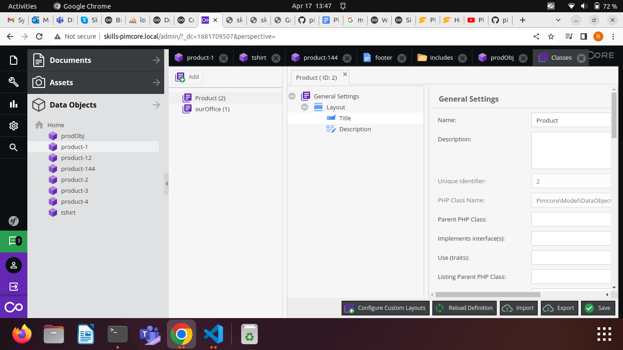

* Now go to the location src > Command
* Create a file named as ProductCommand.php
* Past these code into ProductCommand.php file

<?php

namespace App\Command;

use Symfony\Component\Console\Attribute\AsCommand;

use Symfony\Component\Console\Command\Command;

use Symfony\Component\Console\Input\InputInterface;

use Symfony\Component\Console\Output\OutputInterface;

use Symfony\Component\Console\Style\SymfonyStyle;

use Pimcore\Console\AbstractCommand;

class ProductCommand extends \Pimcore\Console\AbstractCommand{

protected function configure(){

$this->setName('product')->setDescription('this cmd is used to import');

}

/**

* {@inheritdoc}

*/

protected function execute(InputInterface $input, OutputInterface $output){

//Create

$product = new \Pimcore\Model\DataObject\Product();

$product->setTitle('product 144');

$product->setDescription('Test Description');

$product->setParentId(1);

$product->setKey('product-5');

$product->setPublished(true);

$product->save();

$output->writeln('Product is successfull created');

return 0;

//Fetch

// $product =\Pimcore\Model\DataObject\Product::getByPath("Product/product-1");

// p_r($product);

// exit;

}

}

* Now check the command is it ready or not hit this command on project path like as

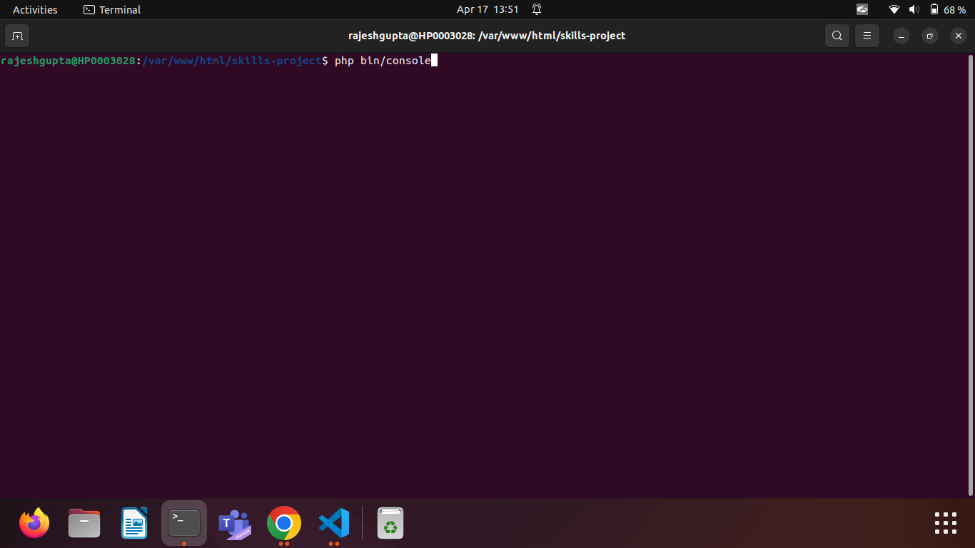

* Now look at the Available commands section it is showing product in list i.e it is created successfully

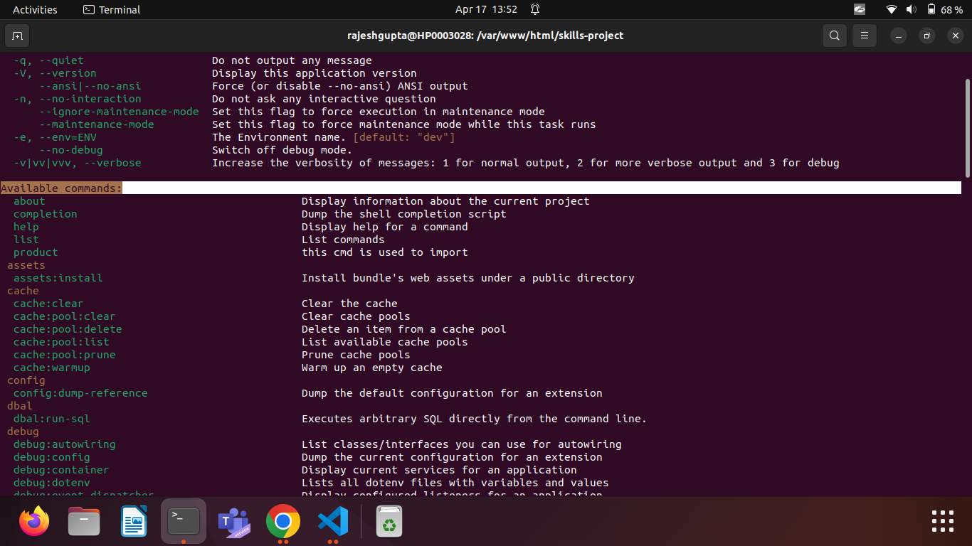

* Now run the command to create Product object by using command hit this command

**php bin/console product**

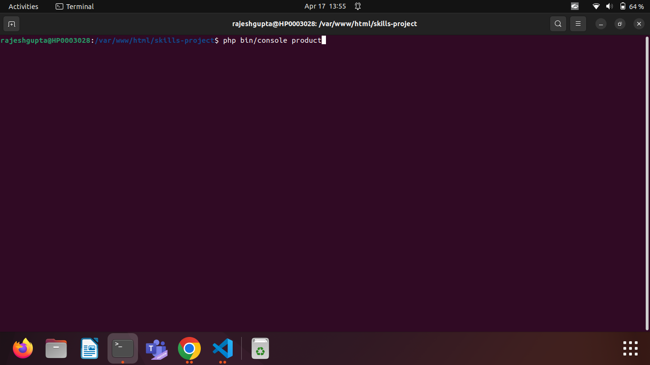

**Now see the console output with admin output**

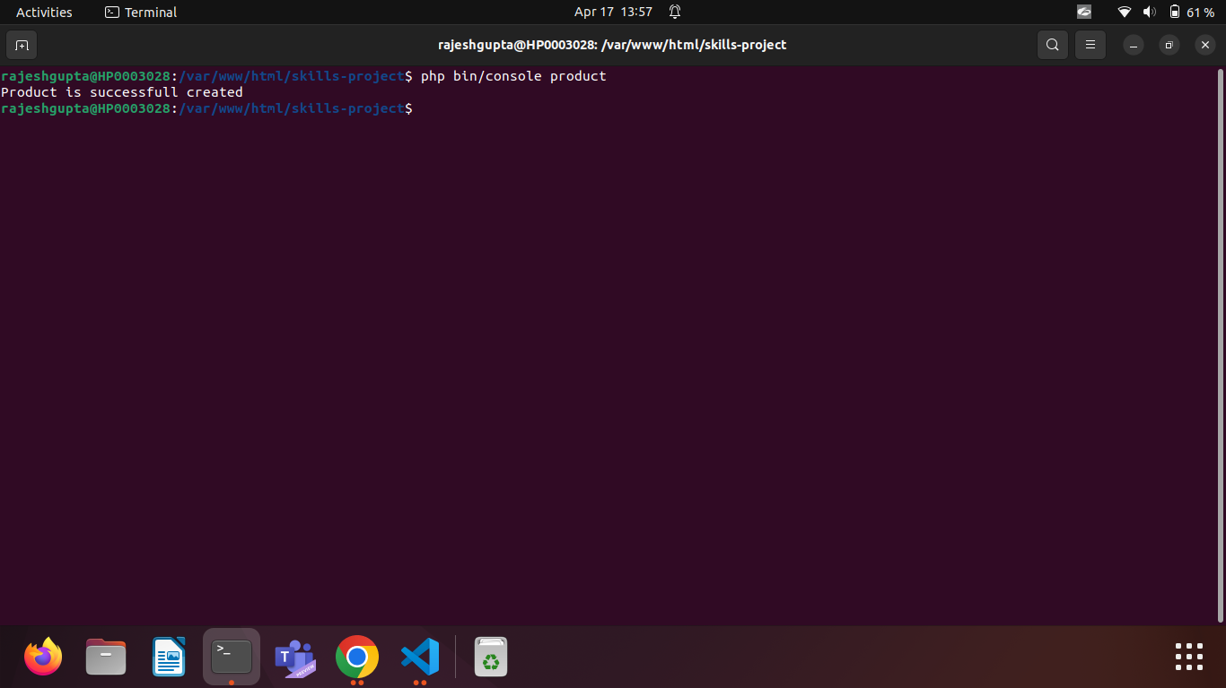

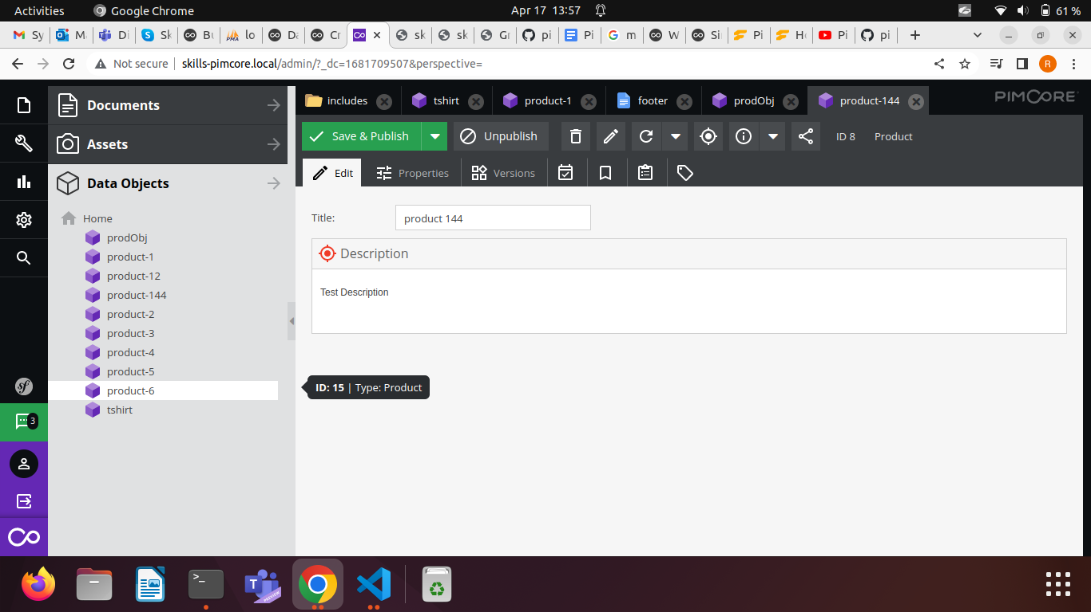

* **Now you have successfully created**